Grazioso Salvare Animal Shelter Dashboard

This is a dashboard that allows a user to identify dogs for training from a database of animal shelters in the Austin Texas region. It uses a MongoDB database to store information and a reusable Python module to connect to the database. The module allows for CRUD (Create, Read Update, Delete) operations on the database. We also created a client-side web application that allows a user to interact with the animal shelter data. The web application has filters that update the data dynamically based on the search and rescue profiles that were configured (Water, Mountain, Disaster).

Motivation

This project was created as a secure, consistent, and scalable way to interact with a database of Austin Animal Center outcomes. It helps abstract the complexity of interacting with the database into a simple web dashboard that anyone can use to help filter the results.

Getting Started
To get a local copy up and running we need the following:
- Database: Ensure MongoDB is installed and running locally. Import the dataset into the aac database.
- Authentication: Ensure that there is a user with readWrite access to the aac database.
- Python Module: Place the CRUD_Python_Module.py file in the same directory as your project.

Installation
To run this project, you will need to have the following installed:
- MongoDB – Chose MongoDB as the database backend because the document structure is flexible and can handle the varied data fields associated with the animal shelter intake forms. MongoDB was choosen because it handles unstructured data well. It also is easy to map to Python dictionary objects.
- Python – Python is used as the core programming language for the logic layer as it is widely used and easy to integrate with MongoDB.
- PyMongo – was chosen as the Python driver for MongoDB because it is the official Python driver for MongoDB.
- Jupyter Notebook – allows for the creation of interactive documents that are useful for testing the sotware.
- Dash – Dash is the framework used to build the front end dashboard that end users will interact with. It provides both the view and controller structure for the dashboard web application.

Usage
Environment
- Ensure MongoDB is installed and running and that the dataset is imported into the aac database.
- Ensure a user called aacuser has been created with readWrite access to the aac database.
- Place the CRUD_Python_Module.py, Project2.ipynb and the Grazioso Salavare logo into the same folder.

Launch the Dashboard
- Run the Project 2 Jupyter Notebook Project2.ipynb
- Open the generated dashboard in a web browser.

Interacting with the Dashboard
- Radio buttons at the top of the dashboard allow a user to filter the dogs by type of training (Water Rescue, Wilderness Rescue, Disaster Response).
- The data table will show the dogs that match the filter.
- The Chart will show the breakdown of dogs by breed.
- The Geolocation map will show the location of the dog selected in the data table.

Steps Taken
For this project I first made sure to import the data from the csv file into the mongodb database aac. Next I made sure to create a user (aacuser) with readWrite access to the database. Then I created the CRUD_Python_Module that is used to connect to the database using python. This module uses the PyMongo driver. Next I created the front end dashboard using Dash. This allows the user to interact with the database in a natural way through their web browser.

Challeges & Solutions
One issues I ran into was that after first writing the dashboard, my pie chart was not updating based on the applied filter. It was stuck on the original data set. I had used df instead of dff in the pie chart so it was not updating with the subsetted data. It ended up being a simple fix just updating the variable to be dff instead of df.

Screenshots
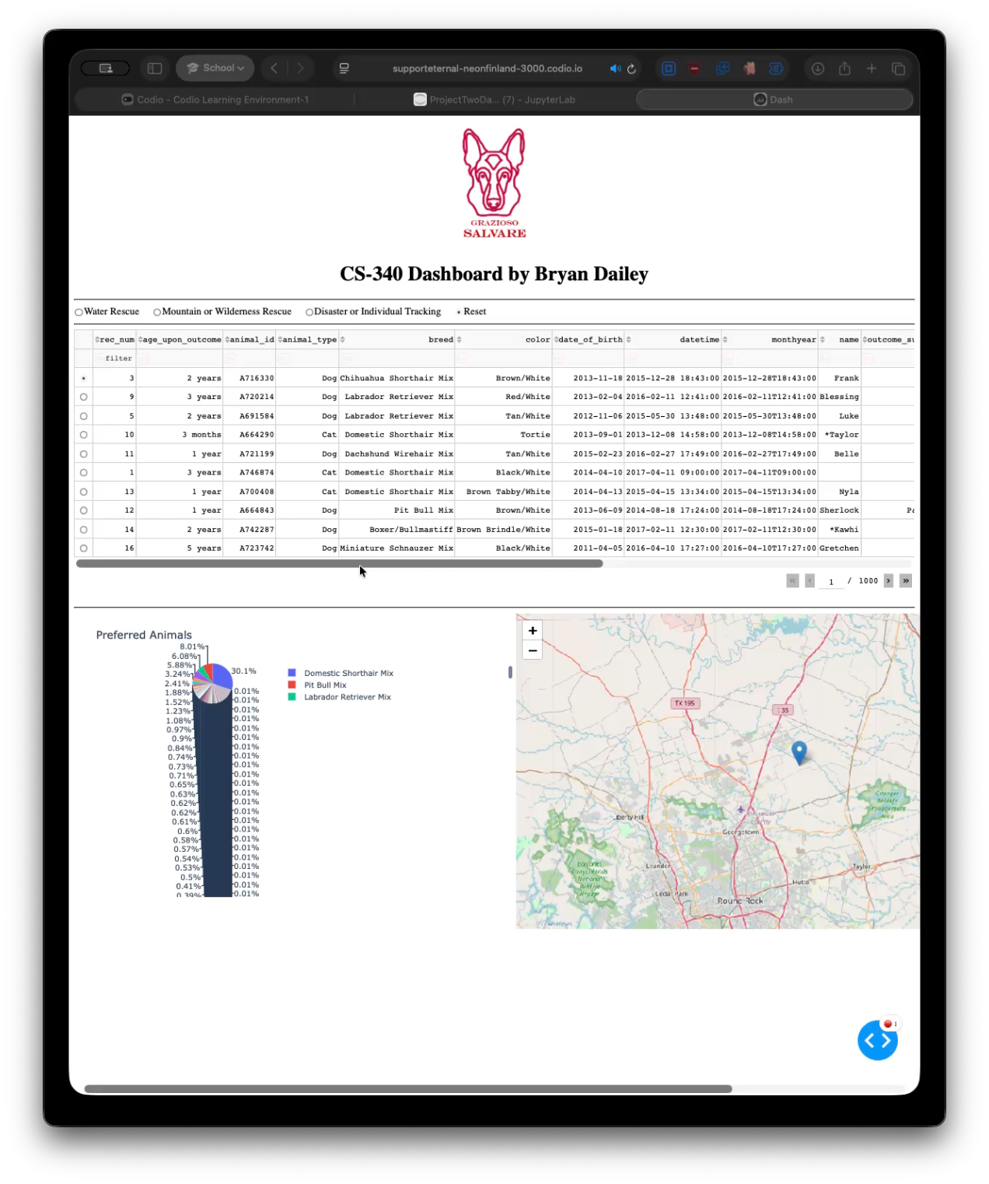
Default view of the dashboard.
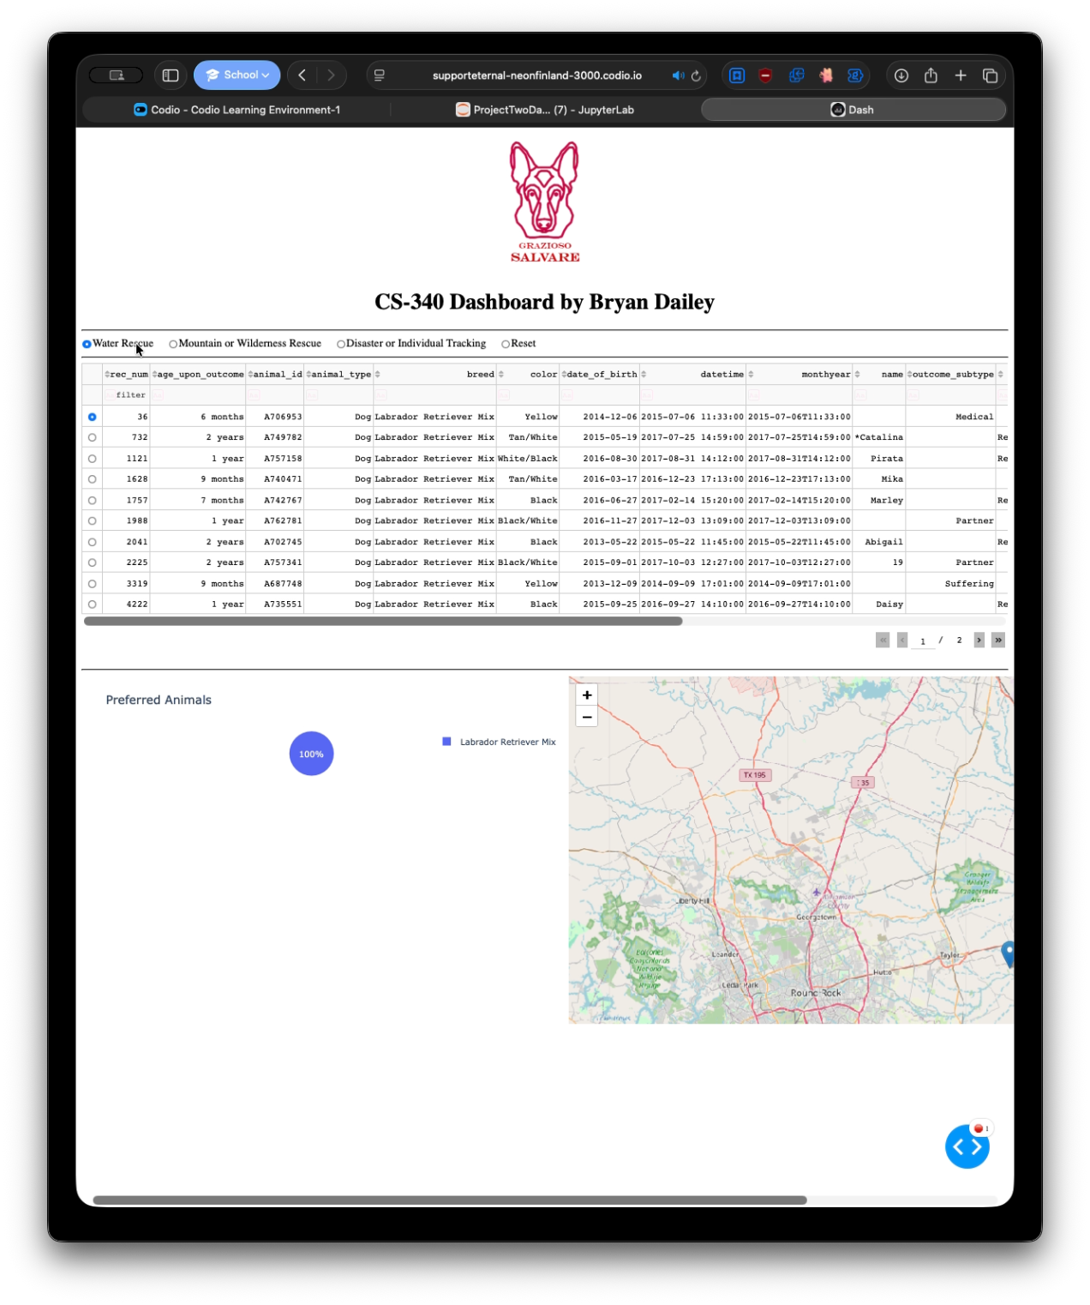
View of the Water Rescue Filter
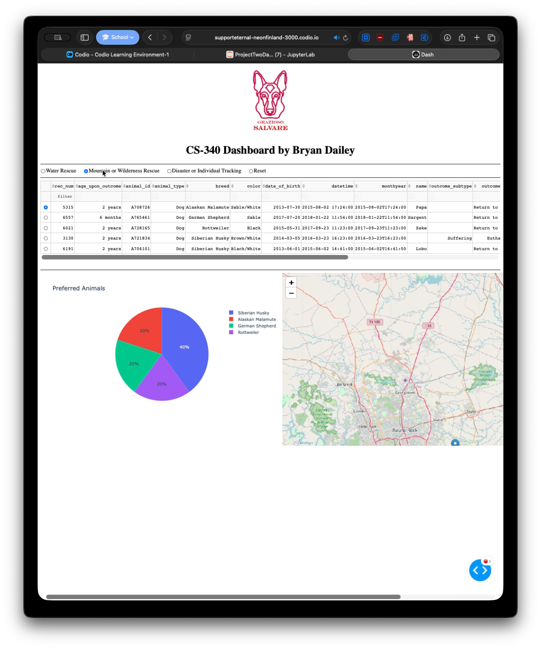
View of the Mountain or Wilderness Rescue Filter
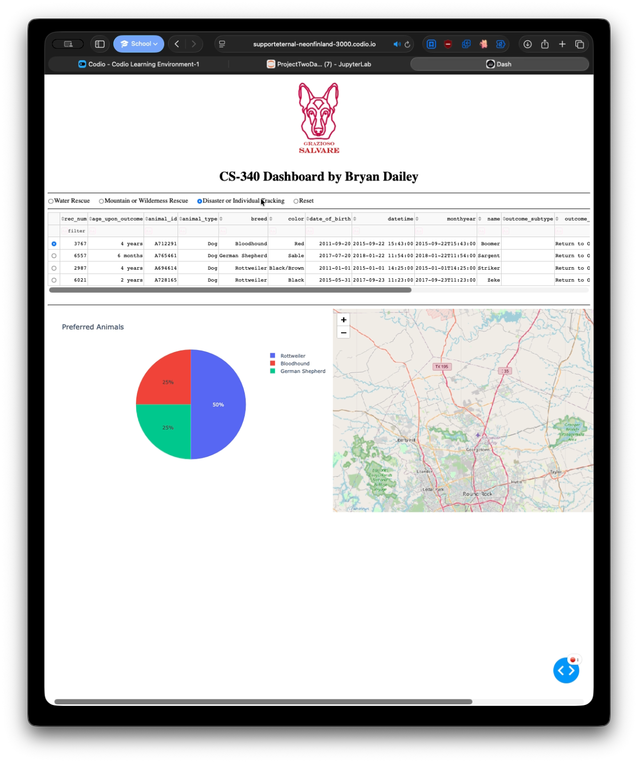
View of the Disaster or Individual Tracking Filter

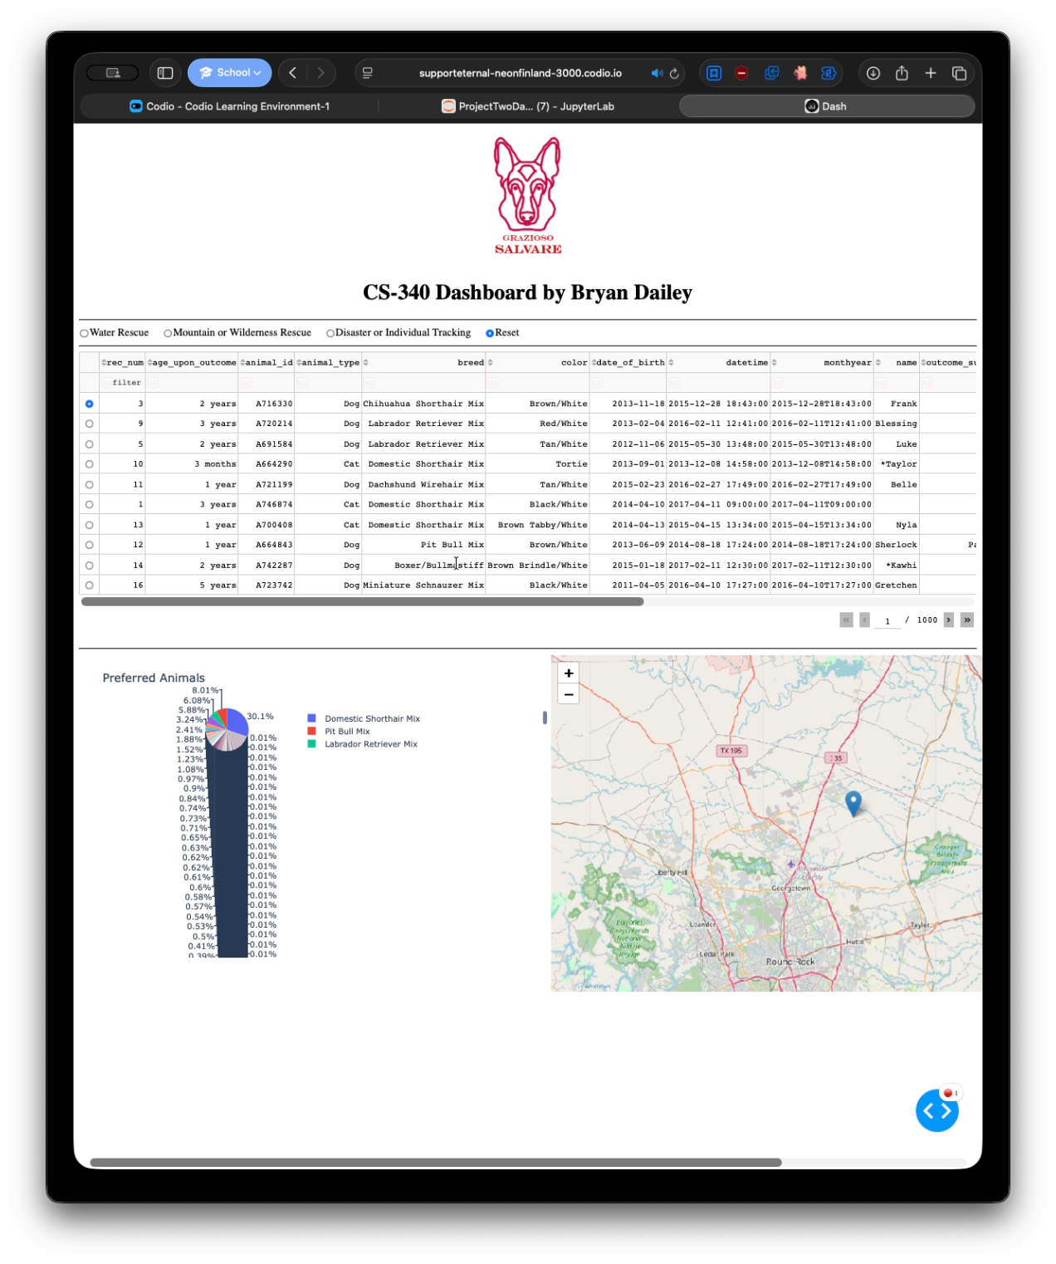
View of the Reset of the Filters bringing it back to the original view.

Contact
Bryan Dailey

